Farm to School
Sub-Grant for Child Nutrition Programs
Summer 2022 Application
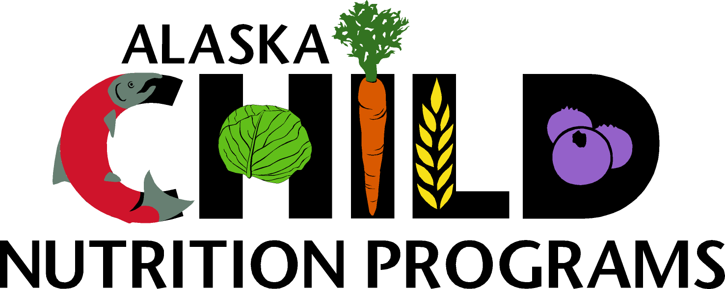
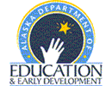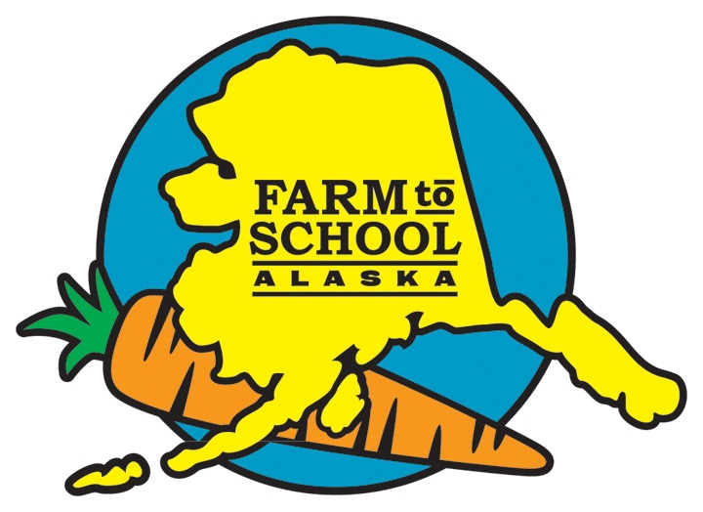

The Farm to School Grant is a United States Department of Agriculture grant operated by:

Child Nutrition Programs
Alaska State Department of Education and Early Development
801 W. 10th St., Suite #200
Juneau, AK 99811

Direct questions to:
Cyde Coil, Child Nutrition Program Coordinator
907.465.8719 or cyde.coil@alaska.gov

Information and Requirements for

Student Health and Academic Achievement Sub-Grants for Child Nutrition Programs

What is Farm to School?
Farm to School is a direct education intervention designed to improve access to local foods in childcare and school settings and provides education opportunities that encourage healthy eating behaviors. Farm to School programs empower children and their families to make informed food choices while strengthening the local economy and contributing to their communities by tailoring their program to the unique needs of their students.

General Information and Program Overview
Farm to school grantees can customize their program to best serve their children and students. This can include incorporating school gardens, hydroponic systems indoors, buying from local producers, etc. Anything that encourages buying local and/or enhances a student’s knowledge of nutrition and where their food comes from.
If you are currently participating in a similar, or the same, grant project you must have a new or altered objective, which demonstrates new development within the project.
Funds cannot be spent prior to award notification; receipts must be dated after award notification.
The Farm to School Grant program will not provide funding for individual salaries.
No more than half of the funds requested can go towards travel costs (such costs may be incurred through field trips to see various fresh Alaskan products).

Grantees will be awarded between $500 and $1,000 per site for their targeted programs. Applications are due on April 30, 2022.

Farm to School objectives and goals:
- Increase the consumption of nutritious foods among students.
- Increase the knowledge of where foods come from among students. Including but not limited to, creating outside or hydroponic gardens for students to participate in growing their own fruits and vegetables.
- Create sustainable alternatives to purchasing food from outside sources. Including but not limited to, working to get more local farmers, producers and/or fish processors around your area to participate in Farm to School Programs.

Program Information

Program Name ______________________________________________

Address ______________________________________________

______________________________________________

Primary project ______________________________________________
Contact name

Applicant’s title ______________________________________________

Phone number ______________________________________________

Email address ______________________________________________

School District Child Care Center Sponsor of Family Day Care Homes
___ Number of schools ___ Number of center sites ___ Number of Homes
participating ___ Number of children in ___ Number of children in attendance attendance

Please list all school and/or childcare sites participating below:

Months of operation:
___ 9 months ___ 12 months ___ other: _____________________________

Proposal
Tell us briefly how your school or childcare agency plans to implement the mini grant:

What are the specific goals and objectives of this project?

What is your media plan? Parent newsletters, posters, announcements, and art all counts as media

How will funds be utilized? You may list any you have. We will need receipts for all funds expended.

How does your project include expertise and collaboration from food service staff? Use this response to explain how the food service will be a part of your project.

How do you plan to involve the children/youth? Please be specific on how children will be involved in the project.

How will your project impact the children’s’/youths’ understanding of the food system?

Please initial by each condition that you have read, understand, and accept these conditions. In applying for the Farm to School Care mini-grant, the applicant agrees to:

- ___ If you are currently participating in a similar, or the same, grant project you must have a new or altered objective, which demonstrates new development within the project.
- ___ Submit claims for reimbursement for this grant by May 31, 2022.
- ___ Purchase budgeted items and provide receipts for all purchases.
- ___ Complete a mini-grant evaluation at the completion of the mini-grant.
- ___ Submit one photo of the grant being implemented.

SIGNATURES (All are required)

We have reviewed this application and attest to the information provided. If selected, we agree to implement the program as outlined above and to implement the project in a manner consistent with the policies and procedures established by the USDA. Further, we agree to participate in any USDA-sponsored evaluations and to provide the information requested. Please provide the contacts shown below or equivalent positions as determined by the school district or agency.

Superintendent or Agency Executive Director __________________________ Date ____________
Food Program Coordinator ________________________________ Date __________
Business Manager __________________________________ Date __________

Completed applications must be received by April 30, 2022

Submit by e-mail, mail or fax to:

Attn: Cyde Coil
Alaska Child Nutrition Programs
Department of Education and Early Development
PO Box 110500
Juneau, AK 99811-0500
E-mail: cyde.coil@alaska.gov
Phone: (907) 465-8719
Fax: (907) 465-8910

